**Pet Supply Store eCommerce Analysis**

-- Total number of sales

SELECT COUNT(*) FROM sales

-- Top 5 customers (in terms of sales revenue)

SELECT s.customer_id as customer, SUM(round(sales::numeric,2)) as sales

FROM sales s LEFT JOIN customers c USING (customer_id)

GROUP BY s.customer_id

ORDER BY SUM(sales::numeric) DESC

LIMIT 5;

-- Top 5 customers (in terms of # of sales transactions)

SELECT s.customer_id as customer, COUNT(sales) as no_of_sales

FROM sales s LEFT JOIN customers c USING (customer_id)

GROUP BY s.customer_id

ORDER BY COUNT(sales) DESC

LIMIT 5;

-- Top 5 products (in terms of sales revenue)

SELECT p.description as product, SUM(sales::numeric) as sales

FROM SALES s JOIN PRODUCTS p USING (stock_code)

GROUP BY p.description

ORDER BY SUM(sales::numeric) DESC

LIMIT 5;

-- Top 5 products (in terms of # of sales transactions)

SELECT p.description as product, COUNT(sales) as no_of_sales

FROM SALES s JOIN PRODUCTS p USING (stock_code)

GROUP BY p.description

ORDER BY COUNT(sales) DESC

LIMIT 5;

-- What region, state and city had the highest revenue? (Top 5 for state and city)

SELECT region, SUM(sales::numeric) as sales

FROM sales s LEFT JOIN customers c USING (customer_id)

GROUP BY region

HAVING region IS NOT NULL  --Filtering out guests

ORDER BY SUM(sales) DESC;

Filtering guest customers

Without filtering guest customers, we can see guest customers account for a large number of sales. Guest customers region shows as [null] since we don’t have their information.

SELECT order_state as state, SUM(sales::numeric) as sales

FROM sales s LEFT JOIN customers c USING (customer_id)

GROUP BY order_state

HAVING order_state IS NOT NULL  --Filtering out guests

ORDER BY SUM(sales) DESC

LIMIT 5;

Filtering guest customers

SELECT order_city as city, order_state as state, SUM(round(sales::numeric,2)) as sales

FROM sales s LEFT JOIN customers c USING (customer_id)

GROUP BY order_city, order_state

HAVING order_city IS NOT NULL  --Filtering out guests

ORDER BY SUM(sales) DESC

LIMIT 5;

Filtering out guest customers

-- Which products got more returns?

SELECT DISTINCT(p.description),

SUM(ROUND(sales::numeric,2)) OVER (PARTITION BY p.description) as sales_returns

FROM SALES s JOIN PRODUCTS p USING (stock_code)

WHERE invoice_no = 'return'

ORDER BY sales_returns

LIMIT 5;

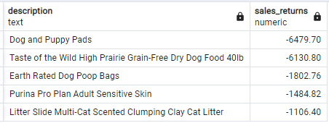

-- Which days of the month generate more sales?

SELECT day, SUM(sales::numeric) as sales

FROM sales

GROUP BY day

ORDER BY SUM(sales) DESC

LIMIT 5;

-- Which days of the month generate less sales?

SELECT day, SUM(sales::numeric) as sales

FROM sales

GROUP BY day

ORDER BY SUM(sales)

LIMIT 5;

It seems the days with higher sales are usually in the first half of the month.

-- Which days of the week generate more sales?

SELECT day_of_week, SUM(sales::numeric) as sales

FROM sales

GROUP BY day_of_week

ORDER BY SUM(sales) DESC

We can see weekdays generate more sales than weekends.

-- Which months generate more sales?

SELECT month, SUM(sales::numeric) as sales

FROM sales

GROUP BY month

ORDER BY SUM(sales) DESC

We can see Nov/Dec (holiday season) as the months with more sales.

-- Top 5 highest shipping cost products?

SELECT description as product, weight, shipping_cost_1000_mile

FROM products

ORDER BY shipping_cost_1000_mile DESC

LIMIT 5;

-- Correlation between product weight and shipping cost?

SELECT round(corr(weight, shipping_cost_1000_mile)::numeric,2) as weight_shipping_corr

FROM products

As expected, there is a high correlation between the product’s weight and shipping cost.

Market Basket Analysis

As a last step, we’ll calculate the product association and confidence taking as guide this very useful article: <https://medium.com/@samratjain/explained-market-basket-analysis-using-sql-a7434f30e649>

Confidence basically states what is the probability of buying product_A given that you bought product_B and the formula is:

Confidence (A -> B) = Support of A and B / Support of B

Where:

Support of A= Number of transactions A was bought in

Support of A and B= Number of transactions A and B was bought together in

*Be aware that C(A -> B) is not the same as C(B -> A)

-- Product association and confidence of buying product 1 given customer bought product 2

WITH product_association AS

(

    SELECT product_1, product_2, COUNT(transaction) as transaction_count

    FROM

    (

        SELECT s1.invoice_no as transaction, s1.description as product_1, s2.description as product_2, s2.invoice_no

        FROM sales s1, sales s2

        WHERE s1.invoice_no = s2.invoice_no

        AND s1.description <> s2.description

        AND s1.description < s2.description

        ORDER BY s1.description

    ) as temp

    GROUP BY product_1, product_2

 ),

 transactions_per_product AS

 (

    SELECT description as product, COUNT(*) as no_of_transactions

    FROM sales

    GROUP BY description

 )

 SELECT product_1, product_2,

 round(transaction_count/no_of_transactions::numeric,2) AS conf_p1_given_p2 -- conf(p1->p2) = support of p1 and p2/support of p2

 FROM product_association pa, transactions_per_product tp

 WHERE pa.product_2 = tp.product

 ORDER BY conf_p1_given_p2 DESC

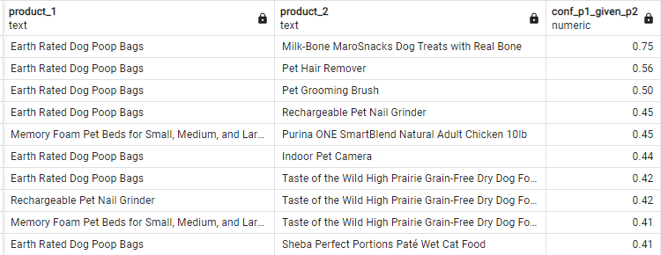

Now doing from the other direction:

-- Product association and confidence of buying product 2 given customer bought product 1

WITH product_association AS

(

    SELECT product_1, product_2, COUNT(transaction) as transaction_count

    FROM

    (

        SELECT s1.invoice_no as transaction, s1.description as product_1, s2.description as product_2, s2.invoice_no

        FROM sales s1, sales s2

        WHERE s1.invoice_no = s2.invoice_no

        AND s1.description <> s2.description

        AND s1.description < s2.description

        ORDER BY s1.description

    ) as temp

    GROUP BY product_1, product_2

 ),

 transactions_per_product AS

 (

    SELECT description as product, COUNT(*) as no_of_transactions

    FROM sales

    GROUP BY description

 )

 SELECT product_1, product_2,

 round(transaction_count/no_of_transactions::numeric,2) AS conf_p2_given_p1 -- conf(p2->p1) = support of p1 and p2/support of p1

 FROM product_association pa, transactions_per_product tp

 WHERE pa.product_1 = tp.product

 ORDER BY conf_p2_given_p1 DESC

